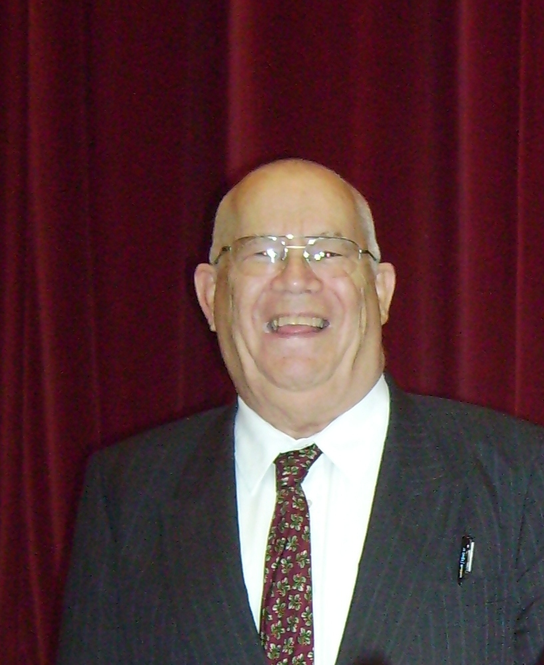
The Parish Council wishes to honour the life and contribution of a long-standing former councillor, Mr Laurie Tucker of Poyle, who died recently - RIP
Laurie was a founder member of the Colnbrook with Poyle Parish Council in 1995, and served on it until May 2011. He became the second person to hold the title of Chairman.
Indeed, Laurie Tucker was the longest continuously serving Chairman in the Parish Council’s history; he played a hugely significant role in shaping the Parish Council, the cohesion of the Parish and the strongly independent identity of our Community.
Laurie was awarded the honour of being a Freeman of the Parish, and he was also a leading member of Christian church locally.
The Parish Council extends its deepest sympathies to Laurie’s wife Beatrice, (Bea Tucker), and their family.

