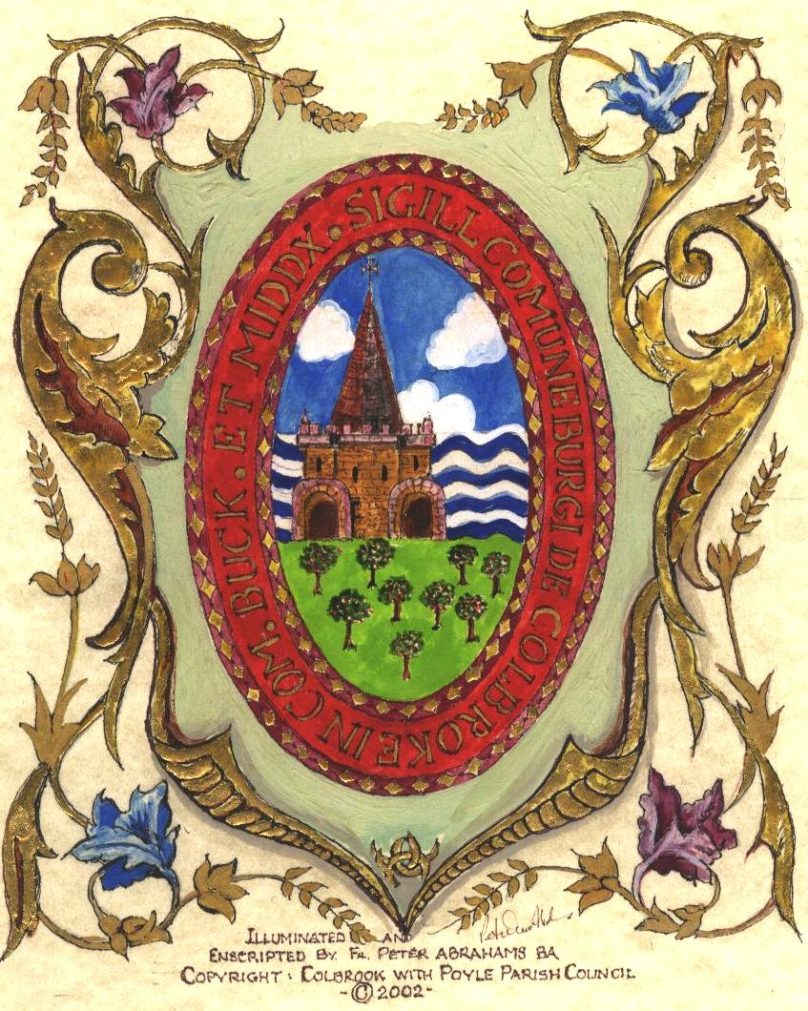

COLNBROOK WITH POYLE PARISH COUNCIL

Parish Council Finance & Policy Committee Meeting Minutes

Minutes of the meeting of the Parish Council Services Committee held virtually via ZOOM on Thursday 16th July at 7pm

Members Present: Councillors (Cllr) Escott (In the Chair), John, Kahlon, and Smith (Cllr Rana - ex officio – to support with technology)
Officer Present: No available
Members of the Public: 0

REF: |  | ACTION POINTS
FP/20/01 | Welcome  The Chair welcomed all in attendance and reminded members that the meeting would be recorded for the purposes of minuting the meeting.
FP/20/02 | Apologies for Absence  Apologies received from Cllr Small & Cllr Babuta
FP/20/03 | Declaration of Interest  None
FP/20/04 | Minutes of the meeting held on 18th February 2020:  Cllr Escott commented that the last meeting was in February due to CV-19  a) Resolved – That the minutes of the meeting held on  18th February 2020 were approved as a true record and signed by the Chair.
FP/20/05 | Payment List:  Payment list from 16th June – 10th July 2020 was reviewed and approved. | Cllr Escott
FP/20/06 | Museum:  Cllr Escott referred to a letter from a resident requesting release of money donated by the Ostrich Inn (£1000) with an inflationary consideration. In addition, in the letter it was suggested that an additional £500 was given as a thanks to the person who had housed the Village’s Fire Tender for circa 4 years.  The payment for keep of Fire Tender was agreed.  The payment from the Ostrich Inn needed to be verified from the written ledgers from 1996.  Cllr Kahlon asked that the council had visibility of the signed letter of agreement referred to in the resident’s letter.  Cllr Escott raised the point that the Parish Council had agreed to fund the museum to the amount of £44.5k and while there had been discussion about the donation from the Ostrich Inn it had never been made clear that this donation was being held by the Parish Council. Cllr Escott indicated that had that been made clear the Council may have determined that the full donation amount was inclusive of all money for the museum project. This was an incredibly generous donation from the residents of Colnbrook to preserve the history of the Village and now more was being sought.  Cllr Smith raised the point that is was included in the letter of intent. Cllr Escott also added that she had not seen any letter of intent and it was discussed in a F&P part II in January which was subsequently removed from the minutes.  Cllr Kahlon indicated that if it can be established the Ostrich made the donation than it should be given to the museum.  Cllr Escott indicated that it appeared a decision was made by the Council with incomplete information and without the knowledge that it was the PC that was holding the £1k donation. It was agreed to put it to the wider council.  Cllr Escott the referred to the conditions that needed to be met by the museum working group in order to be awarded the donation. Cllr Escott informed the committee that she had emailed the Project Manager of the museum to determine the conditions were being met. It was agreed that confirmation that these conditions had been met to release the final donation
FP/20/07&09 | CV-19 decision making:  Cllr Escott shared with the committee the conversation with the internal auditor that day and had been advised that the best way to account for the decisions made via email during lock down was to produce a full payment lists and go through it and discuss the detail and do the same with any decisions made.  Cllr Escott also informed the committee that her initial thought to have an interim audit would not be necessary (as advised by the internal auditor) if the council took the advice from the internal auditor and went through the financial and policy decisions that way. This will ensure the decisions are appropriately minuted.  Cllr Escott asked the committee for comments or if anyone had any different suggestion to ensure decisions were minute. The was agreed by the committee. | Cllr Escott  Cllr Escott
FP/20/08 | CV-19 Grant Award:  Cllr Escott invited Cllr John to speak on the matter.  Cllr John informed the council that the grant was awarded to the Council for Cv-19 to be used for the residents of Colnbrook.  Cllr John suggested that a letter of thanks be sent to SBC fort the £750 awarded and to everyone had donated to support residents.  In addition, Cllr John felt the residents should be informed with some form of communication and an input of how the grant should be used. In addition, that the whole council of 12 should have a say in its use.  This was agreed unanimously by the committee.  Cllr Escott also shared with the council that there was still a substantial amount of food in the Village hall and that their accounts of Colnbrook Cares indicated they had £1200 in reserve and so it could be established that there was no immediate need to release the money.  Cllr Escott also made the point that Colnbrook Cares may be best placed to use the money but rather than making a full payment of £3000 which the PC then had no visibility of, it could be transferred as and when required.  Cllr Escott also made the point that those shielding had been advised that this would be stopped after 1st August and therefore the SSE grant that was specifically for those in isolation would perhaps be better used in the event of either a second wave as Cllr Smith had highlighted on a previous emails, or a local lockdown.  Cllr John added that moving forward that all 12 councillors should be more visible and that could be that some banners are produced to contact the councillors because the banners had worked well. This would add value.  Cllr Smith informed the committee that SBC was in the process of engaging all residents in all wards to get comments from residents about their ongoing needs during the pandemic. This could help the PC could get ahead of what may be needed in the autumn. He added that we needed information of how the money would be used prior to releasing it given we were now coming to the end of the first wave.  Cllr Kahlon agreed that a banner is a good medium to get information across to residents. He also suggested that a CV-19 page be set up on our website to thank residents and volunteers for their contribution.  Cllr Escott also mentioned that linking in with the community development officer may help us get ahead.  Cllr Smith added that we should link with charities so that we don’t reinvent the wheel and get our residents what they need post lockdown, especially if they found themselves in financial hardship. | All
FP/20/10 | Questions & Correspondence to the Chair:  None received.  AOB added due to length of time since F&P meeting:  Cllr Smith indicated that funds had been allocated for various projects and now we needed to get on with delivering some of these things.  Cllr Kahlon indicated CCTV for Westfield would be an action he was keen to pursue.  Cllr John indicated that as a council we needed to improve communication.  A brief discussion took place in relation to receiving written questions from residents to help with keeping meetings to time and allow for robust answers. It was discussed that this shouldn’t replace oral questions but could be an addition.

This part of the meeting closed at 8.04pm.

Signed--------------------------------------------------- Chair Date:

Signed--------------------------------------------------- Clerk Date:

Signed--------------------------------------------------- Witness Date:

