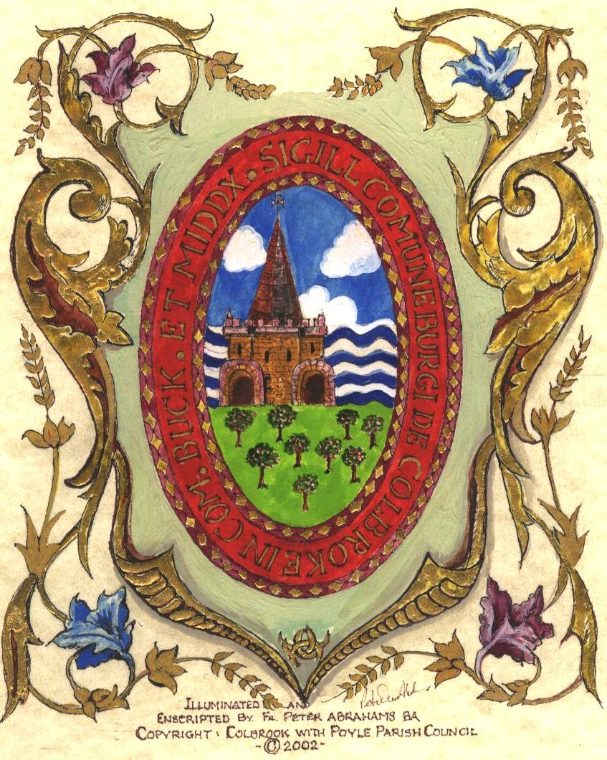

COLNBROOK WITH POYLE PARISH COUNCIL

Parish Council Services Committee Meeting Minutes

Minutes of the meeting of the Parish Council Services Committee held at the Village Hall, Colnbrook on Tuesday 14TH JANUARY 2020 at 7:35pm

Members Present: Councillors (Cllr) Bennett (In the Chair), Oakley, Richardson
Officer Present: Mrs J. Freeland – Finance Assistant
Members of the Public: 2

REF: |  | ACTION POINTS
Ser/19/039 | Welcome  The Chair welcomed all in attendance.
Ser/19/040 | Apologies for Absence  Apologies were received from Cllrs Bedi, Rana, Virdi,
Ser/19/041 | Declaration of Interest  None.
Ser/19/042 | Minutes of the meeting held on 12 November 2019  a) Resolved – That the minutes of the meeting held on  12th November 2019 were approved as a true record and signed by the Chair.
Ser/19/043 | Christmas 2019 Washup Sessions  Cllr Bennett gave an update on the Christmas trees:-  - One tree had been stolen from Sovereign Heights, there had been an issue with connection for the lighting of the 2 new trees, this to be resolved prior to the trees being installed next Christmas.  Resolved – That the update be noted.
Ser/19/044 | Recreation Ground  Inspection Report – Has been received and there is a need for repairs to be carried out before anything is done on new project.  Need the right company to do the work, companies to be invited to look at repairs required and quote for the work.  Cllr Oakley commented that at the CCP meeting the fencing/ barrier around the Crown Meadows/Horton Brook needs to be repaired to stop fly tipping. The area has been cut back and the rubbish has been cleared.  Cllr Bennett would also like sensor lights on each corner of the Recreation Ground.  Green Flag Application – Due to the time constraints Mr Angell and Mr Jackson will put the application together. Cllr Oakley asked that there be a handover following this and prior to the next application.  Cllr Oakley had taken a taken a tour with Colne Valley Regional Park who showed him where the runway will be and what impact it would have on the area. Following this Cllr Oakley would like to put forward a motion that the Council make a contribution of £2,500 per year for a period of 5 years and fixed to inflation. They could attend a Council meeting every 2 months to give an update on what they have carried out. It was agreed to make this recommendation to the Finance meeting and then the full Council meeting.  Resolved – That the update be noted. | Cllrs Bennett/ Bedi  Cllrs Bennett/ Bedi  Cllr Oakley
Ser/19/045 | Questions & Correspondence to the Chair  A question regarding the use of Westfield Hall was asked from the public and it was confirmed that it was the Parish Councils official office.  It was also noted that there had been interests received in relation to the Locum Clerk position and that interviews would be taking place.  Cllr Oakley informed that the CCP advised that £2,500 would be given towards the museum trust.  Resolved – Noted
 | Committee members noted that the next meeting would be on Tuesday 11th February 2020.

The meeting closed at 8.20pm.

Signed--------------------------------------------------- Chair Date:

Signed--------------------------------------------------- Clerk Date:

Signed--------------------------------------------------- Witness Date:

